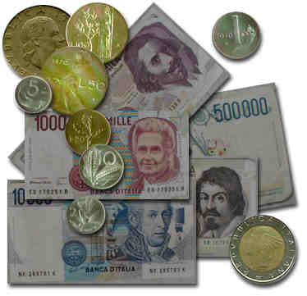

QUARTA PROVA: IL TEMPO È DENARO

What is the Italian currency?

____________________________________________________________________________

What was the previous Italian currency?
____________________________________________________________________________

How many Euro notes are there?

______________________________________________________

How many Euro coins are there?

______________________________________________________

