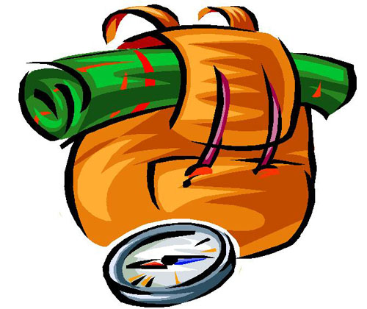
THE PERFECT TRAVEL MATE
Choose you travel mate from the list below and get ready for your 3-day trip!

- Paolo – L’ARCHEOLOGO
Paolo studies archaeology at the University of Udine. He wants to visit three different Roman ruins. You can meet him in Grado, a small town in the Friuli-Venezia-Giulia region, where he lives. He would like to have a look at Aquileia and then go to Rome and Pompei.
- Linda – LA STILISTA
Linda is a “fashionista”. She would like to become an International fashion designer, so she travels a lot in order to find inspiration and new ideas to develop her own brand. Help her to find the new trends: Milano, Roma and Positano are the three spots that people recommended her to visit.
- Matteo – IL MECCANICO
If you are looking forward to get a driving licence to drive a fast, luxurious, expensive cars, Matteo is the perfect travel mate for you! He is very passionate about motors and knows everything about Italian cars. He is about to go to Turin where he will visit the “centro storico FIAT”, then he will go to Monza and Maranello.
- Sara – LA NUOTATRICE
Sara’s nickname is the “mermaid”: she loves swimming, fishing, rowing and going to the seaside. If you love the sea, she is the friend you are looking for! She would like to have a look at Genova which is famous for the “salone nautico” annual exhibition, then move to Verona to have the chance to meet her hero, Federica Pellegrini, and finally enjoy the sunshine in Palermo.
- Sonia – LA SCIATRICE
Sonia loves the snow! She is really sporty and she is learning how to ski. She has 3 days to make the most of it. She wants to leave from Aosta, in the North West of Italy to get to Trento and arrive to Tarvisio, close to the border with Austria. Do you want to join her?
- Simone – IL LETTORE
Simone wants to become a writer, so he reads tens of books every month! He would like to visit “il salone internazionale del libro” in Torino. He is interested also in how books come to life, that is why he will go visit Mondadori book publisher's office in Milano and Giunti's headquarter in Firenze.
- Paolo – LO CHEF
Paolo is studying hard to become a chef. In order to pass his exam he has to create a special dish with unique ingredients. He thought that he could look for “tartufi” in Pesaro Urbino, in the Marche region, then go to Napoli for some “mozzarella di Bufala” and then move to Palermo to learn how to make the perfect “cassata”.
- Lara – LA GOLOSA
Lara has a sweet tooth, so she wants to visit three cities to taste their fabolous desserts and sweets. She planned to leave from Perugia where she wants to visit the famous Baci's Factory. Then, she will move to Napoli to taste the delicious “Pastiera napoletana” and finally she will go to Palermo to learn how to make a “cassata”.
- Francesco – IL CALCIATORE
Milan, Inter, Roma, Juventus... Francesco is keen on Italian soccer! His dream? To visit the biggest Italian stadiums! Francesco wants to start with “Stadio delle Alpi” in Torino, then go to “San Siro” in Milan and finally enter the “stadio Olimpico” in Rome! Maybe he will have the chance to meet his heroes!
- Lucrezia – LA BALLERINA
Lucrezia has been dancing since she was a child. She wants to have a look at the Italian theaters where the most incredible ballet dancers have performed: “La Fenice” in Venezia and “La Scala” in Milano. But she would like also to have fun and go to the most famous discoes of Rimini.
- Sandra – L’ATTRICE
Sandra loves soap operas and dreams to become a movie star. That is why she would like to visit Torino and Napoli where the Italian soap operas “Centro Vetrine” and “Un posto al sole” are set. She would love also to stop at “Cinecittà” in Roma to have a look at the place that made Italian cinema so famous in the 50s.

- Giacomo – IL CANTANTE
Please don't stop the music! Giacomo sings “al piano bar” every Saturday night, but he dreams he will be a famous singer! In Italy the most famous singers perform at San Siro Stadium in Milan, at “Stadio Olimpico” in Rome or are able to fill up piazza del Pleibiscito in Napoli with thousands of fans. If you want to have a look at these beautiful cities, get ready to rock!
- Maria – LA PITTRICE
Michelangelo, Raffaello, Leonardo... Italy is the homeland of the most important artist of all time. If you are interested in art, go with Maria to Venezia where the Biennale is held, then go to the Uffizi Gallery in Firenze to have a look at those incredible works of art and

- Pietro – IL MOTOCICLISTA
Lives in Urbino, the town where Valentino Rossi was born. He has passion for Moto GP and Italian motorcycles. He wants to show you around his home town before visiting the factory museums of Ducati in Bologna and Moto Guzzi in Mandello de Lario, near the famous Lake Como.

